**Project Design Phase-II**

**Technology Stack (Architecture & Stack)**

Date

12 October 2022

Team ID

Project Name

PNT2022TMID42403

Project - Intelligent Vehicle Damage

Assessment and Cost Estimator for Insurance

Companies

Maximum Marks

4 Marks

**Technical Architecture:**

The Deliverable shall include the architectural diagram as below and the information as per the table1 & table 2

**Example: Order processing during pandemics for offline mode**

**Reference: <https://developer.ibm.com/patterns/ai-powered-backend-system-for-order-processing-during-pandemics/>**

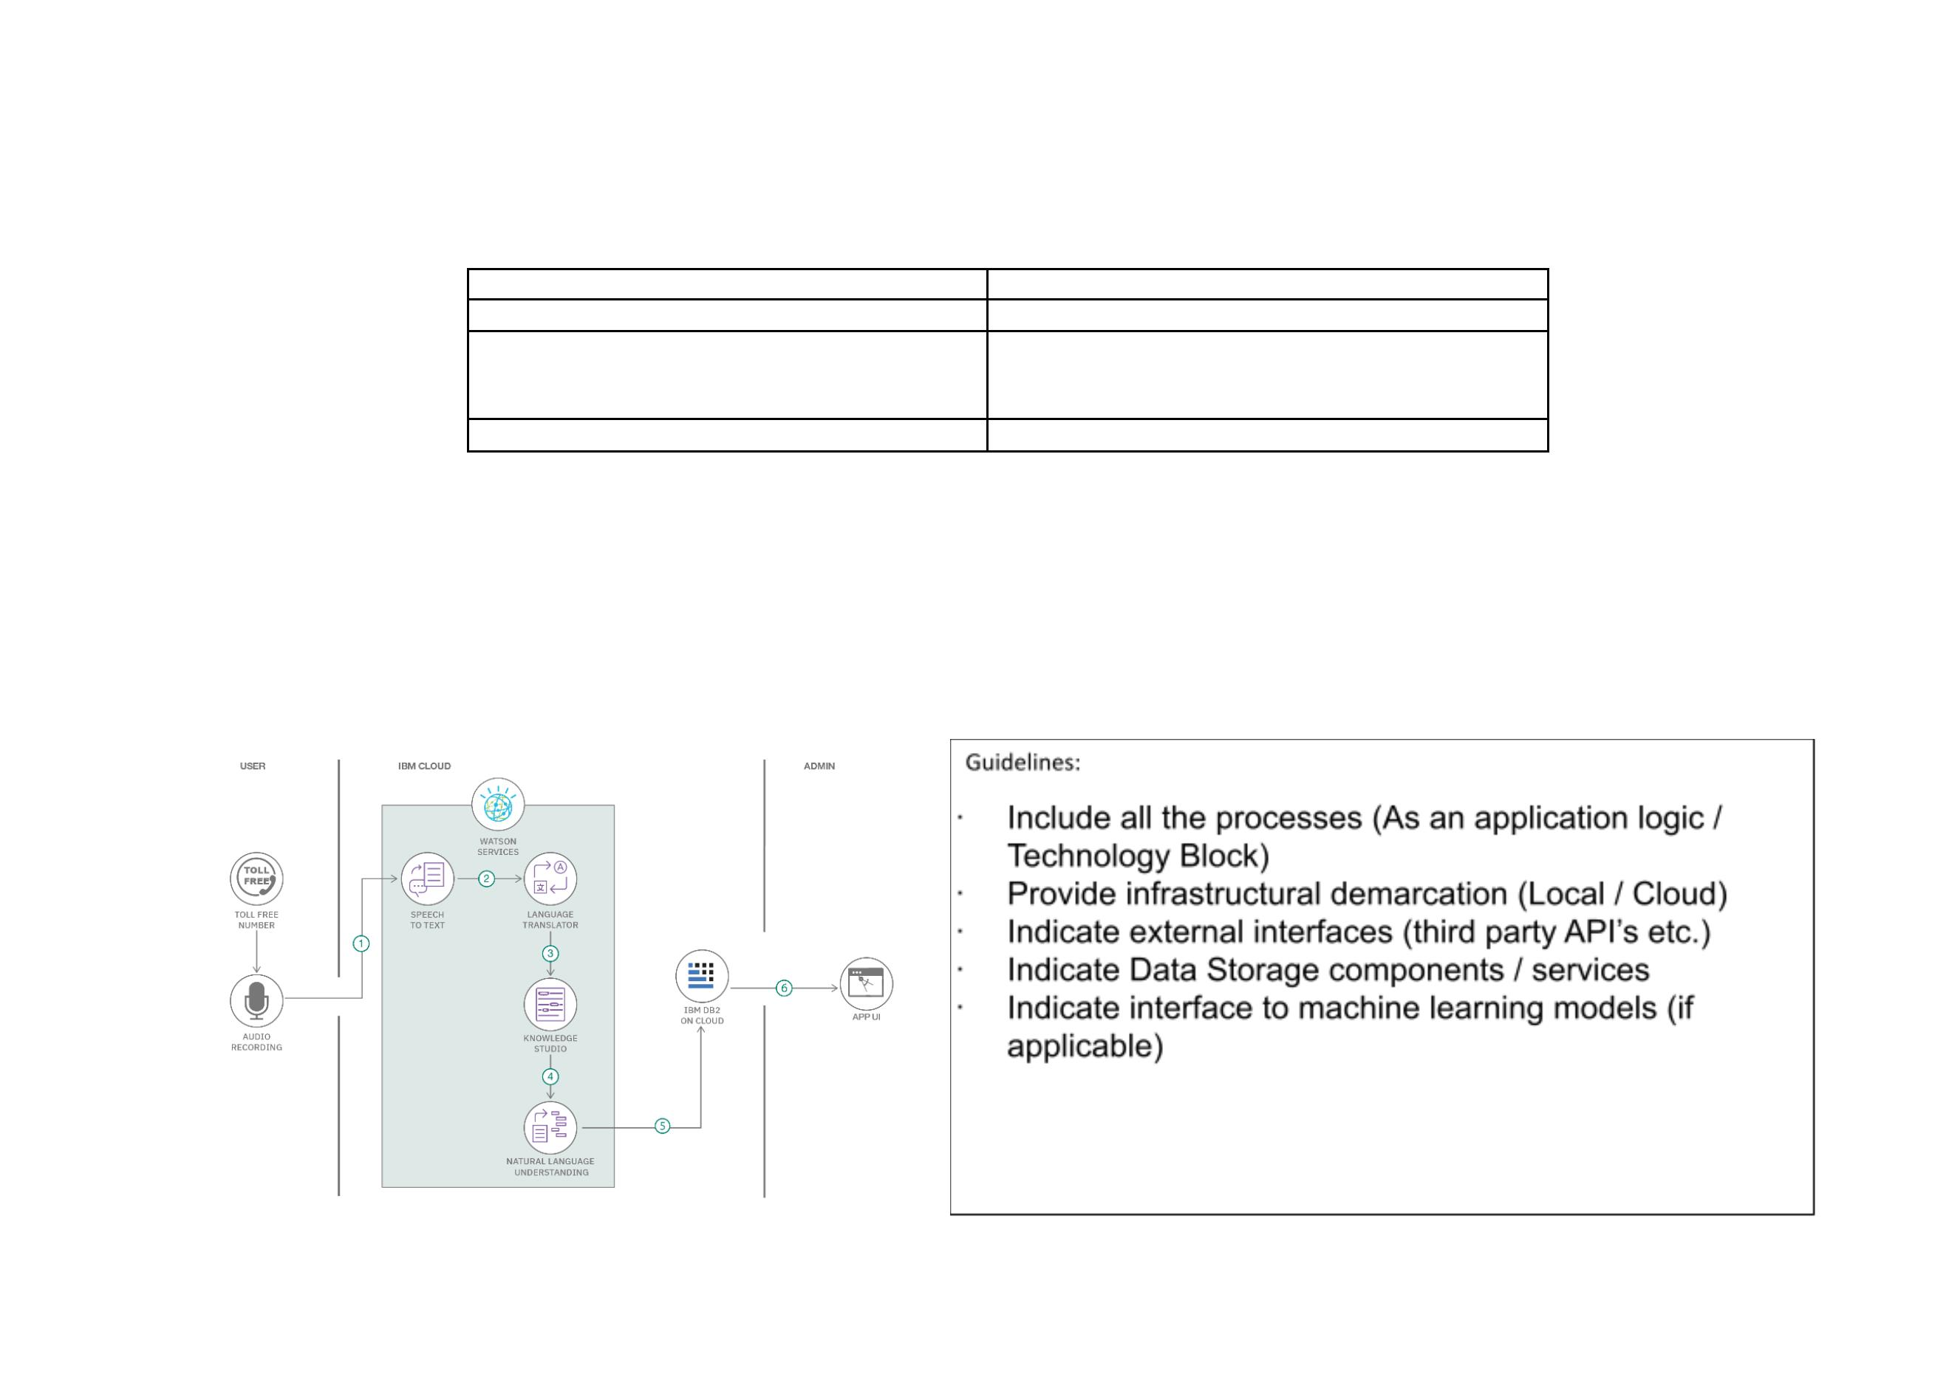

**S.No**

**Component**

**Description**

**Technology**

1.

User Interface

How user interacts with application e.g.

Web UI, Mobile App, Chatbot etc.

Logic for a process in the application

HTML, CSS, JavaScript / React Js.

2.

3.

4.

5.

6.

7.

Application Logic-1

Application Logic-2

Application Logic-3

Database

Javascript

Logic for a process in the application

Logic for a process in the application

Data Type, Configurations etc.

Database Service on Cloud

IBM Watson STT service

IBM Watson Assistant

MySQL, NoSQL, etc.

IBM DB2, IBM Cloudant etc.

Cloud Database

File Storage

File storage requirements

IBM Block Storage or Other Storage

Service or Local Filesystem

IBM Weather API, etc.

8.

9.

External API-1

External API-2

Purpose of External API used in the application

Purpose of External API used in the application

Purpose of Machine Learning Model

Aadhar API, etc.

10. Machine Learning Model

Object Recognition Model, etc.

Node js.

11. Infrastructure (Server / Cloud)

Application Deployment on Local System / Cloud

Local Server Configuration:

Cloud Server Configuration :

**Table-2: Application Characteristics:**

**S.No Characteristics**

**Description**

**Technology**

1.

2.

Open-Source Frameworks

Security Implementations

List the open-source frameworks used is IBM

watson

IBM cloud

Technology of Open Source framework

e.g. SHA-256, Encryptions, IAM

Controls, OWASP etc.

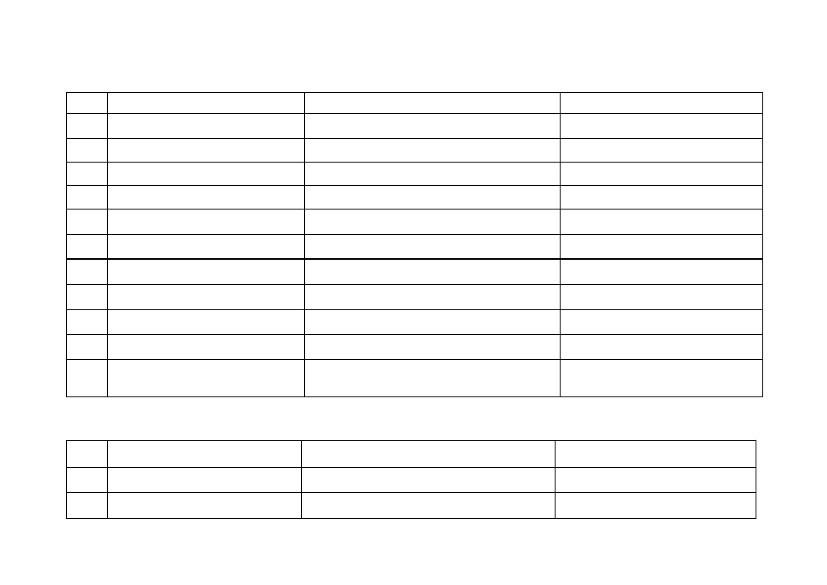

**S.No Characteristics**

**Description**

**Technology**

3.

Scalable Architecture

Web Server – Static and dynamic website content

residing on the website is updated based on user

requests and suggestions. Application server - can

perform basic functional updates of the website

and integration of new logic into his website

Database is constantly changing based on input

from the user.

IBM Watson Assistant, Python, MySQL

4.

5.

Availability

AI models are made available to users instantly at

any time.

IBM Watson –automate processes, The deep

studying version is skilled in the usage of IBM

Watson studio for higher overall performance and

short accessibility.

IBM Watson Cloud assistance

IBM Watson Assistant

Performance

**References:**

**<https://c4model.com/>**

**<https://developer.ibm.com/patterns/online-order-processing-system-during-pandemic/>**

**<https://www.ibm.com/cloud/architecture>**

**<https://aws.amazon.com/architecture>**

**<https://medium.com/the-internal-startup/how-to-draw-useful-technical-architecture-diagrams-2d20c9fda90d>**

